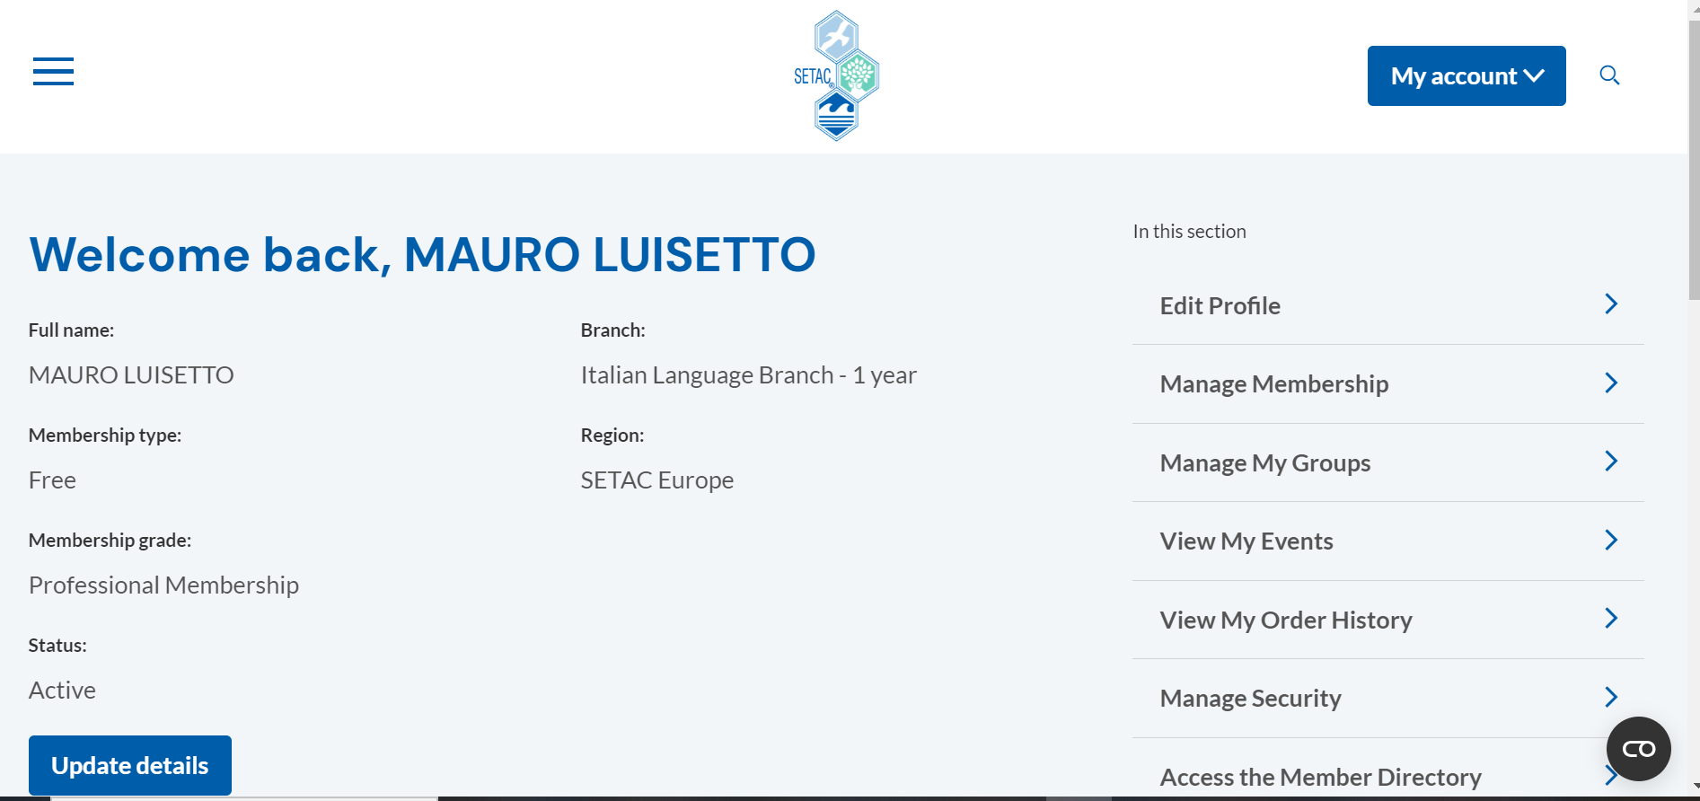
Setac membership luisetto mauro 2024-2025
SETAC
The Society of Environmental Toxicology and Chemistry (SETAC) is a global, non-profit professional organization. With nearly 20,000 members representing more than 3,400 organizations from across 90 countries, SETAC is dedicated to the advancement of environmental science and management.

